Summary of scorecard for UNDP 2011

  - Mandate
UNDP is active in the areas of poverty reduction, environment, good governance, crisis prevention and recovery, and also has an important task as coordinator of the UN’s development activities. It is playing a leading role in the UN’s reforms and in improving coordination between UN agencies.

  - Financial scale and contribution
With a budget of almost USD 6 billion UNDP is the largest operational UN programme in the field of poverty reduction. The Netherlands is an important donor for UNDP and in 2008, 2009 and 2010 contributed EUR 90 million in core funds. Non-core contributions related mainly to governance, democratisation, rule of law, emergency aid, conflict prevention and reconstruction. In 2011, in line with the government’s cutbacks, the core contribution was reduced to EUR 66.3 million.

 | 2010
Total | USD 5.95 billion
Dutch contribution | USD 220 million
Percentage of total | 0.37%
Ranking NL | 5

  - 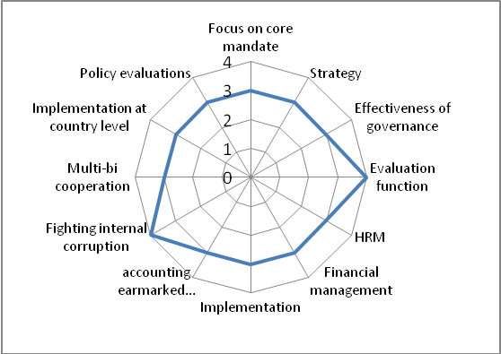Institutional factors and internal functioning are sufficient to good, focus could be stronger
UNDP adheres to its mandate, which is however relatively broad and could be more focused. The Programme plays a pivotal role within the UN, but could profile itself more forcefully as part of the UN system rather than competing with other UN agencies. Its cooperation with other development actors is sufficient. UNDP is considered a valuable partner by local partners and is appreciated in the field for its convening power. Its financial position is sufficient, although the relative decline in core contributions is a point for attention. The audit and evaluation systems are of good quality, and anti-corruption measures receive considerable attention.

  - 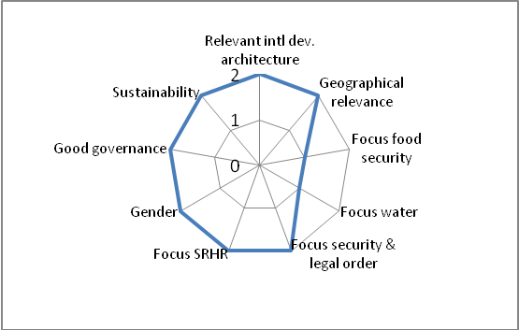Policy relevance in security and legal order, SRHR (including HIV/AIDS), gender, good governance and sustainability
With its mandate as a coordinator and its impartiality UNDP plays a key role in addressing crises and conflicts in more than 60 countries. It is a co-sponsor of UNAIDS and Principal Recipient of the GFATM in 27 countries. A high percentage of UNDP’s activities are aimed at promoting democratic governance. It has a clear policy on gender. Environment/sustainable development is one of UNDP’s core areas of activity and it is working on integrating environment into development plans and supports countries’ efforts to adapt to climate change.

  - Details
With its coordinating mandate, worldwide presence, impartiality and convening power, UNDP has a central function within the UN system and at country level. The trust it enjoys among (interim) governments enables UNDP to play a unique role in sensitive areas like democratic governance and in crises and other fragile situations.

