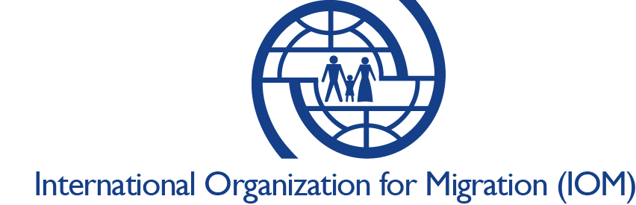

**Position paper**

***Topic****: Roundtable on migration, humanitarian aid & human trafficking*

***Where****: Dutch House of Representatives*

***Date****: 30-10-2017*

*------------------------------------------------------------------------------------------------------------------------------------------*

* IOM feels the goal of sound migration policy should not be to stop migration or solely to achieve a reduction in arrival numbers; rather, successful policy must be based on ensuring migrants’ rights and increasing their protection and well-being.
* We are convinced that the number of arrivals we have been seeing over the past few years is manageable for Europe as a whole acting in solidarity with front-line states.
* People are the concern, not the numbers. Of greater concern than the arrival numbers:
* the continuing high rate of fatalities,
* numerous instances of inhumane treatment and rights violations,
* the actual needs of the migrants in transit, in Libya, and arriving to Europe, especially for women and children,
* the dearth of adequate legal channels to Europe,
* and the complete absence of any dialogue about the positive aspects of migration.
* The exclusive focus on prevention and security is making migration an increasingly toxic and polarizing issue.

IOM welcomes the objective of better regulating rescue operations in the Mediterranean Sea in the interest of safeguarding the lives and security of both migrants and operators.

* We hope the Code of Conduct will lead to improved coordination of ALL actors and states involved in SAR operations in line with international law, and will ultimately enhance rather than limit life-saving work.
* We also express great concern over the action of anti-migrants boats in the Mediterranean trying to stop NGOs from rescuing people.  This particularly worrisome manifestation of a xenophobia not only has no place in European culture and values, it is potentially deadly for migrants.
* The EU, MS and the international community should stand with one voice against such groups not only in the Mediterranean but everywhere, and we should take care that policies and rhetoric do not have the unintended effect of “fueling their boats”.
* We reiterate that sea arrivals via the Mediterranean sea place a disproportionate burden on states located on the southern borders of the European Union and therefore call for the fair sharing of responsibilities and greater solidarity with front-line states, such as Italy.  This should entail a strengthening of EU-led search and rescue, with more EU states contributing resources to save lives -- as well as more robust participation in the EU relocation scheme.
* While all States must respect international maritime law and come to the rescue people in distress at sea, at the same time, the reception of rescued migrants cannot be seen as an issue only for Italy, but a matter for Europe as a whole.

IOM believes the discussion should be put back on track. Saving lives is the paramount consideration and responsibility of all actors involved, and we are worried that this has taken a back seat to other concerns.

IOM is concerned about the negative depiction and associations pinned on NGOs/SAR and migrants themselves. (Recall that approximately 40% of all rescues carried out at sea in 2016 were done by NGOs).

Saving lives at sea has NOT constituted a pull factor and NGOs/SAR cannot be blamed for increased departures from Libya and arrivals to Italy.  This has been proven by the fact that when Mare Nostrum ended, arrivals by sea *did not* decrease, but actually increased. We want to drive home the fact that push factors (conflict, instability, poverty, state fragility or collapse, persecution, climate and environmental degradation) are far more significant than any possible pull factors.

We need to remind people that saving lives at sea is not only a moral duty, but also a legal obligation, and this debate is negatively affecting the public's perception of this unquestionably essential endeavor.

* Rescue at sea must also be met with more serious measures to provide alternatives to smugglers and deadly routes, primarily more safe and legal ways to bring migrants to come to the EU to work in high, medium and low skilled jobs, contribute to economies, start new enterprises, and fill gaps in the labor market left by an increasingly ageing European workforce”
* Any naval operations outside of Libyan territorial waters should not contribute to any form of “push back” or *refoulement* given the current conditions in Libya, which IOM and UNHCR have jointly stated cannot currently be considered a “safe third country” (refer to the Feb 2017 joint IOM-UNHCR statement). All rescue vessels need unhindered access to international waters.
* While we applaud efforts to improve capacity for rescue of lives at sea, we strongly caution that this must go hand in hand with measures to dramatically improve conditions for migrants in Libya. Currently, the return to Libya of rescued of migrants means (re)exposing people to potentially inhumane and degrading conditions.  The challenge is to avoid the paradox of rescuing people at sea back to conditions where they could die on the land.
* Rescued migrants brought back to Libya must therefore have their rights respected and needs attended to with adequate provision of protection and assistance, health care, screening for vulnerabilities, legal options and other information.
* The conditions in the detention centres are unacceptable. We are therefore working on two-tracks in Libya regarding the detention centres: a) to propose alternatives to the detention centres (more open reception centres) especially for the most vulnerable migrants; and b) working to improve the living conditions for detained migrants.
* The real linchpin is the stabilization of Libya.  Migration management efforts and community-level stability projects can contribute to stabilization, but we must also realize that until Libya becomes less fragmented and more stable, migration management will remain a serious challenge.  At the same time, we must continue to improve conditions for Libyans and migrants caught up in the instability, in addition to more safe legal channels and options for humanitarian return, will reduce the chances that people will seek out smugglers and risk their lives to leave Libya by crossing the Mediterranean.