Due Diligence, Living Income, and purchasing practices

The chocolate sector is a strong supporter of Due Diligence regulation
Four years ago, some of the largest cocoa and chocolate companies in the world collectively asked for mandatory human rights and environmental due diligence (mHREDD) legislation. Decades of voluntary initiatives had clearly shown the inability of voluntary initiatives alone to deliver on sustainability promises. The whole cocoa and chocolate sector rallied around this call, and in the following years, the joint sector – working in a collaboration called the Cocoa Coalition – developed a series of position papers on why this is necessary, and what elements must be part of such a regulation.

OECD Guidance
For this, a strong framework of mHREDD regulations is necessary – at both EU and at national levels. These regulations should be fully compliant to OECD Due Diligence Guidance, and we note with concern that the EU current drafts – though moving in that direction – are still far from OECD-compliant. This will cause a lof of unclarity in the implementation, and for the sake of the businesses that need to comply, all mHREDD regulations should be brought to full OECD-alignment.
The Dutch regulation can receive a much stronger support from us, because it is in-line with OECD compliance. However, there are two major components missing in the regulation, two components that build on each other.

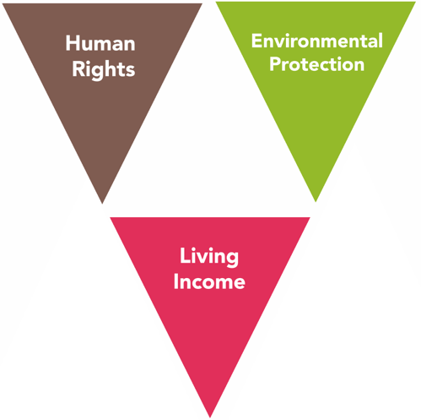
Living Income
At the root of almost all environmental and human rights challenges lies the dire poverty of farmers and wage workers. Major threats such as child labour or deforestation are made so much harder to tackle because of the poverty of cocoa growing households. Any strategy to address these challenges, must by default also address the root cause of farmer poverty. As such, for them to be effective, any mHREDD regulation must include requirements on living wage and living income.
This, too, is one of the key asks of the cocoa sector towards requlators, asking to “include the right to an adequate standard of living, including a living income, as a fundamental human right, as embedded in Articles 23 and 25 of the Universal Declaration of Human Rights and Articles 7 and 11 of the International Covenant on Economic, Social and Cultural Rights.”

Purchasing Practices
Though living income as a concept has become a key objective for the cocoa sector in the past few years, it hasn’t changed core business activities so far. Research from the recently released 2022 Cocoa Barometer shows that the favoured approaches so far to raising farmer poverty are not going to bridge the income gap; higher yields do not necessarily lead to increased net income but do lead to greater risks for farmers. The data is clear; Good Agricultural Practices and Governance Policies alone will not bridge the income gap; Purchasing Practices need to change as well. In fact, without proper Governance and Purchasing Practices, there often is no business model for Good Agricultural Practices.
These purchasing practices include farm gate prices paid, as well as the way that risk is shared by not just the first producers but also by the often more powerful downstream purchasers. This could include long term asymmetric contracts, giving the farmers more rights and protections, etc…
As the Cocoa Coalition put in her latest position paper on Due Diligence regulations: “Companies’ purchasing practices are critical elements in mitigating against the risk of human rights abuses and environmental harms. This is particularly the case in agricultural supply chains where farmer poverty is prevalent, including cocoa...” The Coalition goes on to state that regulation “should incentivise companies regularly to review their purchasing models”.
Furthermore, the risk that corporations will transfer the cost of compliance to the first producers – who are generally the most vulnerable as well – can also be mitigated through requiring decent purchasing practices.

Enabling Environment
Though an essential building block, mHREDD is not a magic bullet and will not solve all the challenges. It must be coupled with strengthening of the enabling environment, such as infrastructure, rule of law, etc. However, the United Nations Guiding Principles on Business and Human Rights are clear; even when the enabling environment is not in place and producing governments are not meeting their responsibilities, corporations must respect human rights – and not trash the environment.

Summary
The cocoa sector is a strong supporter over due diligence regulations. But beyond the standard sustainability approaches, these regulations will have to require tackling the root causes of unsustainability, including providing a living income. This will have to include the requirement to regularly review the purchasing practices, including the prices paid at farm gate and contractual de-risking of farmers.
This document was prepared in January 2023 for the Dutch Parliament by Pomasi Ismaili – Chairman, Cocoa Abrabopa Farmers Association, and Antonie Fountain – Managing Director, VOICE Network.

An overview of their positions, all the companies involved, etc. can be found at www.voicenetwork.cc/due-diligence
This paper deals with the issue of living income, as cocoa is a crop largely grown by smallholder farmers. A very similar situation exists in supply chains that deal more with wage workers, and the issues around living wage and income should both be addressed in any mHREDD, bearing in mind that there are also specific challenges for both interventions.
From: https://voicenetwork.cc/wp-content/uploads/2022/09/Cocoa-Coalition-CSDD-response.pdf
See; www.cocoabarometer.org

