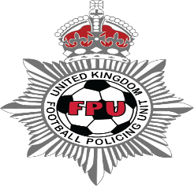

Position paper
Netherlands, Standing Committee for Justice and Security Meeting
31st January 2024

UK Football Policing Unit and the Crown Prosecution Service
This note covers.
- UK best practice in the approach against football hooligans.
- Technical and tactical policing. Detection and investigation.
- Specific football legislation and the importance of “Football Banning Orders”

A partnership approach.
The Crown Prosecution Service and the Police whilst independent, work collaboratively to make watching and participating in football safe and inclusive.
To be effective the following are key.
- The importance of establishing professional relationships between stakeholders
- Understanding the extent of the problem that is football related criminality
- Working together to provide the court with the best evidence to use the legal tools available to prevent criminality in football.

The approach to identifying and policing risk supporters is represented in the graphic below (figure A). The approach is aimed at,
- Empowering those who attend who present no risk (the majority)
- Influencing those who may become problematic by effective prevention and communication.
- Isolating and remove those who are intent on causing crime and disorder.

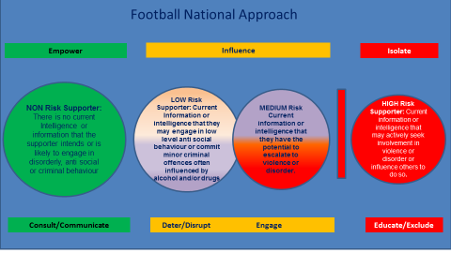Figure A

Policing Structure

- A network of Dedicated Football Officers across all of our major football leagues – one nominated officer per club (116)
- A National Coordination team – the UK Football Policing Unit, sitting under the National Police Chiefs Council
- A Football Banning Order Authority (sitting within the UKFPU)

The role of police at football events

- Safety Operations are the responsibility of the event organiser (Football Clubs)

- Professional Football Clubs require a Ground Safety Certificate to operate INSIDE THE STADIUM

- Police attend in support of the safety operation INSIDE THE STADIUM

- Section 25 of the Police Act 1996 - Special Police Services (SPS) is the provision by the police of an additional special service i.e., beyond that which the police would consider necessary to meet their public duty obligations, and which is provided at the request of organising bodies of certain events and for which the organising body must pay.

- UKFPU provide additional funding for proactivity against crime and disorder including obtaining a Football Banning Order

Crown Prosecution Service (CPS)

The CPS appoints a national lead prosecutor to assist with policy and issues as they arise.
The national lead oversees a network of prosecutors spread nationally with a focus on football related issues.

The issues
The graphic below (Figure B) highlights the areas that are a present risk in football.
It is vital to have a comprehensive information and intelligence gathering function to recognise the issues, develop policies/tactics and understand how to address these.

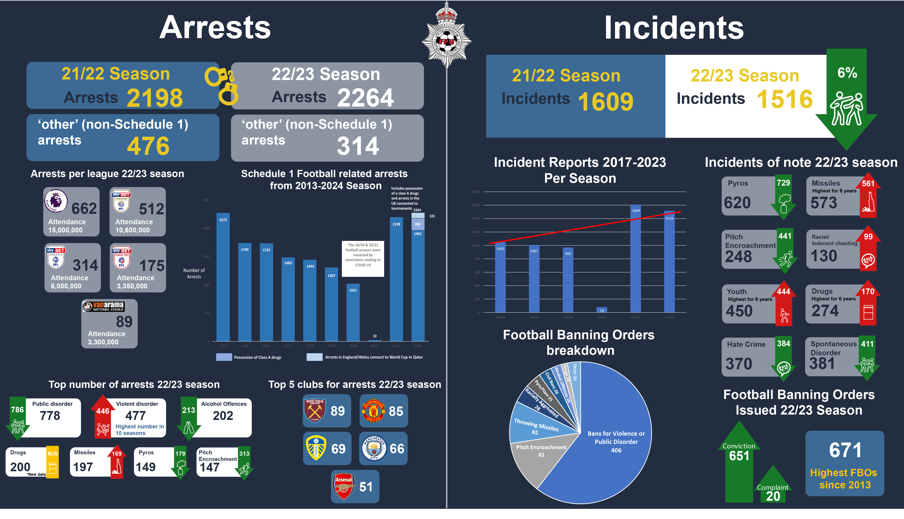
Figure B

There was a general decline in behaviour in football following the return of supporters to football after the Covid pandemic. This resulted in an increase in all areas of disorder and subsequently an increase in arrests, convictions and football banning orders. Whilst there has been a slight improvement in the figures from the previous year, we are still witnessing a level of crime and disorder that is high compared to the previous five years.

Specific legislation for football
Legislation has developed since the 1980’s to tackle the changing nature of criminality in football.
1 Football (Offences) Act 1991
This created specific offences of,
- Throwing of missiles onto the playing area or into the crowd
- Racialist or indecent chanting at a football match - s.3
- Going onto the playing area - s.4

2 Criminal Justice and Public Order Act 1994
Made it an offence for,
- Unauthorised persons ("ticket touts") selling or otherwise disposing of a ticket to a designated football match - s.166

3 Sporting Events (Control of Alcohol etc.) Act 1985
Created specific offences for,
- Carrying alcohol in vehicles on route to designated sporting events - ss.1 and 1A
- Possession of alcohol at or upon entering a designated sporting event - s.2(1)
- Being drunk at a designated sporting event - s.2(2)
- Having a flare or firework etc. at any time during the period of a designated sporting event when in any area of a designated sports ground from which the event may be directly viewed, or while entering or trying to enter a designated sports ground at any time during the period of a designated sporting event at the ground – s.2A​.​

However, it is also quite common to rely on the full remit of criminal legislation is available for football related criminality. Typically, the following are considered,
- Offences Against the Person Act 1861
- Public Order Act 1986
- Criminal Damage Act 1971
- Misuse of Drugs Act 1971

Therefore, a full range of ancillary orders is available depending on the nature of the offence.
It is also important for the law to develop around the changing nature of football related criminality. Recent examples of this include,
- Addressing homophobic chanting
- Tragedy related abuse
- Protest cases
- Expanding the scope of offences for which FBO’s are available (For example, possession of drugs in stadia/ sending offensive digital communications aimed at those with a “prescribed connection” with a football organisation)

Football Banning Orders

The Football Spectators Act 1989 (FSA) created the legislative framework for Football Banning Orders (FBO’s).

FBO’s are an essential tool for controlling access to football matches for those who engage in football related criminality.

Those subject to FBO’S are prevented from attending prescribed football matches.

Failing to comply with a FBO is a criminal offence.

Two types of Football Banning Order

Section 14A FSA

These are FBO’s made on conviction for a criminal offence.
An order will be made where a person is convicted of a “relevant offence”, the court must impose a FBO in addition to any sentence for the offence,
“Unless it considers that there are particular circumstances relating to the offence or the offender which would make it unjust in all the circumstances to do so”
(With effect from 29/6/2022)
The Court MUST make an order or state in open court reasons as to why it did not.

Section 14B FSA

These are FBO’s made under the civil law. They can be obtained for example when there is evidence of football related criminality obtained from abroad and allow for action to be taken against those who commit football related offences overseas. The test for obtaining a 14B order is that the prosecutor must show

- That the person has at any time caused or contributed to any violence or disorder in the UK or elsewhere
- And that the order would help prevent violence or disorder at or in connection with regulated football matches

The consequences of banning orders

- Requirement to report to a specified police station within five days, and surrender their passport when required and report to a police station during the "control periods" associated with "regulated football matches" outside of the UK.

- FBO’s can be made more effective by the use of schedules containing additional restrictions, such as a restricted zone around a ground for a period of two hours before to two hours after a match, and a prohibition on using the railway without the prior approval of the British Transport Police.

- The court may, on application by the prosecutor, order a person on whom a Football Banning Order has been made to attend a specified police station within seven days at a specified time to have a photograph taken

- Breach of a banning order is a criminal offence that carries a maximum penalty of 3 months imprisonment.

- Enforcement is monitored by the police Football Banning Order Authority.

Douglas Mackay
Deputy Chief Crown Prosecutor, CPS West Midlands
National lead for criminality in sport

Mick Johnson
Director of UK Football Policing Unit

29 January 2024

