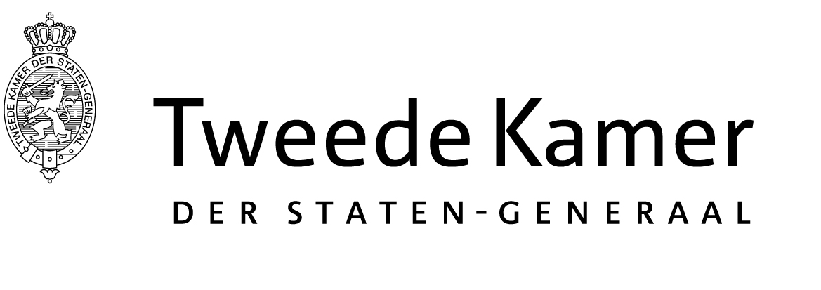 | Commissie Financiën
The Honorable Derek KILMER
1410 Longworth House Office Building
Washington, DC 20515
United States of America
The Hague, May 17, 2019
Dear Representative Kilmer,

As a Dutch Parliamentarian and Chairman of the Dutch Parliament’s Finance Committee, I want to thank you for the increasingly strong bonds between our two countries. The Netherlands is a close U.S. ally in Europe, historically the third largest foreign investor in the United States, and a leader alongside the United States in fighting terrorism. The United States and the Netherlands will co-host the June 2019 Global Entrepreneurship Summit in The Hague, and we look forward to welcoming Secretary of State Pompeo, Secretary of Transportation Chao, and other U.S. government dignitaries.

Despite these very positive developments, the Finance Committee has some concerns about the U.S. Foreign Account Tax Compliance Act (FATCA), about which I am writing you today. The Committee is particularly worried about constituents who are dual Dutch-U.S. citizens who have come to us saying they are unduly burdened by FATCA requirements. These are oftentimes people born outside the United States to U.S.-citizen parents who eventually settled in the Netherlands, or individuals who left the United States as children and have not lived there since. Many have few or no ties with the United States and no Social Security Number (SSN).

Based on the provisions of the tax treaty between the Netherlands and the United States, these individuals do not owe income tax in the United States due to payment of tax obligations in the Netherlands. However, they must still file tax returns in the United States each year, which is a process that, to them, is complicated and costs time and money that many who are low- and middle-income do not have. If they want to renounce U.S. citizenship, they must have filed tax documents for the last five years and pay a renunciation fee of $2,350.

Because FATCA requires foreign banks to provide the U.S. Internal Revenue Service with a SSN for any customers who are U.S. citizens, this group of American citizens who are also Dutch citizens are having problems accessing financial services, such as opening bank accounts, obtaining mortgages, and participating in pension plans. Due to concern by Dutch financial institutions about complying with U.S. regulations, some Dutch banks are cutting existing service and refusing new service if a customer is a U.S. citizen without a SSN. As you can imagine, living without banking services in today’s society is very difficult, if not impossible. It also runs contrary to EU regulations. Although the aim of FATCA is to combat tax evasion, it is unfortunately affecting many people who are unlikely to evade taxes because they have little income or assets.

My Committee would like to ask for your support in seeking to address the unintended negative consequences of FATCA for Americans who are also citizens of other countries. We would propose the following two measures for your consideration, which we believe could be applicable to all FATCA-signatory countries:

- Permanently waive FATCA reporting requirements for individuals with an annual income of less than $70,000 or overall assets of less than $210,000, as certified by banks in FATCA-signatory countries.

- Temporarily reduce the renunciation fee to a more manageable amount for individuals who have annual income of less than $70,000 or overall assets of less than $210,000. We suggest this could be applicable for the period of one year before and one year after the date that FATCA reporting requirements come into full force in a particular foreign country.

I thank you for your consideration of these proposals. If there is anything we can do to assist, or if you would like to talk further, please do not hesitate to let me know.

Yours sincerely,

Anne Mulder
Chair of the standing committee on Finance
House of Representatives of the States General

