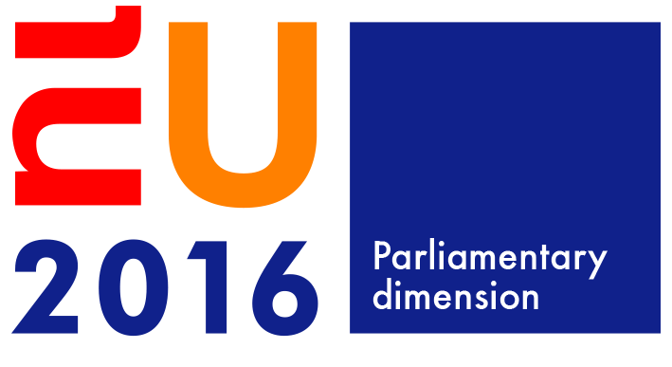 |  | Interparliamentary conferences  Dutch EU Presidency 2016
To Ms Andreea Niculiu
Strategic Policy Officer
Cabinet of the Director
FRONTEX
cabinet@frontex.europa.eu
Place and date: | The Hague, February 12, 2016
Concerning: | Invitation to be on a panel during the migration session of the Interparliamentary Conference on Human Trafficking in the Digital Age on Monday March 14, 2016 in The Hague, The Netherlands
Our reference: | 2016Z03155/2016D06321
Dear Ms Niculiu,
As you may be aware, the Netherlands holds the rotating Presidency of the Council of the European Union during the first six months of 2016. As part of the parliamentary dimension of the EU Presidency, the Dutch Parliament will organise an Interparliamentary Conference (IPC) on Human Trafficking in the Digital Age from Sunday 13 till Monday 14 March 2016. In light of the current migration crisis, the Parliament has decided to organise a session on migration within this conference.
The conference will be attended by +/- 100 key legislators: national parliamentarians dealing with human trafficking and migration in the 28 national parliaments of the EU as well as members of the European Parliament.

The migration session opens with a key note speech from the Minister for Migration of the Netherlands, Mr Klaas Dijkhoff. After this keynote speech there will be introductions from a panel consisting of renowned experts in the field of migration.

As chairs of the political committee that prepares this conference we would like to invite you as one of five key note speakers during a panel discussion scheduled in the afternoon of Monday March 4, 2016 from 14.15 until 17.00 hrs. We would be delighted if you, as Strategic Policy Officer at the Cabinet of the Director of FRONTEX could give a short introduction on the work of your organisation in the migration crisis. For this panel we also invited representatives of the European Commission, the European Asylum Support Office, UNHCR and an academic. We would be most grateful if you would be willing and available to be on the panel in The Hague. Travel- and accommodation expenses are covered.

We very much look forward to working with you and your staff in the preparation of this panel discussion. For further information please refer to the clerk of the migration session, Ms Brechje Hessing-Puts, on parleu@staten-generaal.nl, or telephone +31-70-3183361.

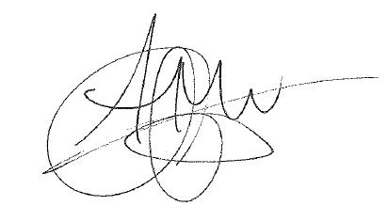
We are looking forward to hearing from you.
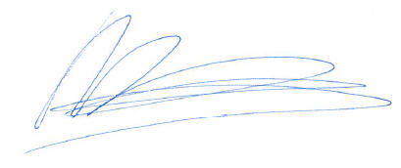
Yours sincerely,

Ms Arda Gerkens Ms Marith Volp
Co-chair of the Political Preparatory Group Co-chair of the Political Preparatory Group
on Human Trafficking on Human Trafficking

