**Mohamad Yahya Maktabi**

[[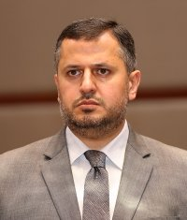](http://en.etilaf.org/media/k2/items/cache/8b072d4f47fa16702f8c7356d2c88ee8_XL.jpg)](http://en.etilaf.org/media/k2/items/cache/8b072d4f47fa16702f8c7356d2c88ee8_XL.jpg)

* Political :Syrian National Council
* City:Damascus
* Date of Birth:Friday, 03 February 1967
* Place of Birth:Damascus
* Educational attainment:General Sciences University of Damascus, License in Accounting, 3rd year of Islamic
* Sex:Male
* Additional Information:Revolutionary Command Council in Damascus, Financial and Administrative