ERFA – Position Paper

**Overview**

First off, for discussions on rail freight, it is important to present the market structure of rail freight. Liberalisation of the sector has been a success. Today, 55% of the European market is challengers and new market entrants. Whilst the total market share has remained stagnant, it would have declined without market opening. This is because, unlike historical incumbent operators, new market entrants are international and corridor focused – reflecting how freight moves.

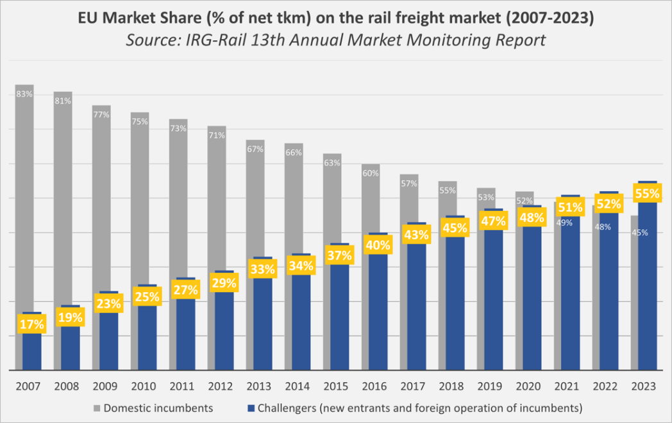

Today, over 50% of all European rail freight crosses at least one border. Of the total rail freight transport volume (including intermodal transport) in the Netherlands, 93% was international in 2024. Of the total rail freight transport in the Netherlands, more than 65% of the transport volume is related to the port-industrial area of ​​Rotterdam. Meanwhile, infrastructure is organised on a national basis. Rail freight is therefore attempting to operate international services on a patchwork of national networks.

**Current Situation**

Today, rail freight in central Europe is burdened by high levels of infrastructure works. Whilst needed, these works have little international coordination or focus on capacity. Rail freight transport also regularly suffers from disruptions to the rail infrastructure due to overdue maintenance and postponed renewal, also in the Netherlands. Both lead to [significant disruptions](https://mykn.kuehne-nagel.com/news/article/germany-faces-extended-closures-impacting-rai-28-May-2025) and [increased costs](https://www.maersk.com/news/articles/2024/07/31/rail-deviation-surcharge). For instance, in August 2024 Maersk introduced a €55 surcharge per TEU for rail bookings to/from Rotterdam. This is because railway undertakings need to bare the financial costs of rerouting. In 2026, for line closures in Germany alone, it is expected railway undertakings will have additional infrastructure usage costs of 132m EUR. This has an impact on costs for customers and contributes to reverse modal shift.

At the same time, long term stability is needed on infrastructure costs (also known as Track Access Charges). Freight TACs for the minimum package in Netherlands were 3.19 to € 3.83 EUR per train-km[1] in 2021 and included a temporary subsidy € 1.59. In 2025 1.55 to 1.86 EUR per train-km and in 2026 2.23 EUR per train-km. Compared to neighbouring countries, the Netherlands has extremely high infrastructure charges for marshalling and shunting freight trains. A weekend of parking a freight train cost in the Netherlands EUR 143 in 2022, EUR 1,200 in 2025 (after a temporary subsidy of EUR 936) and EUR 534 in 2026. In Belgium, there are hardly any charges for marshalling and shunting. In Germany, the charge is now EUR 234. Road transport does not pay parking charges. Infrastructure costs are therefore quite volatile and, in many countries, there is not long-term visibility on what the cost will be in two years time.

The issue here is that contracts are usually made with freight customers up to two years in advance of transportation. This leads to a situation whereby rail freight undertakings need to agree to transportation contracts without having full visibility on the infrastructure costs. Railway undertakings need to include a buffer in their quote (making them less competitive), absorb the additional costs or pass them onto customers.

**Recommendations**

In the short-term, it is essential there is an international and capacity focused approach to planned works. A capacity focused approach means that works should be planned in a way that they facilitate at least 80% of planned traffic on diversionary routes. Given the additional costs, compensation schemes should be introduced to ensure that rail freight is not made less competitive and support for operations should be put in place, such as parking sidings.

In the long-term, Member States should agree to an ambitious agreement on the revision of the [railway infrastructure capacity regulation](https://eur-lex.europa.eu/legal-content/EN/TXT/?uri=celex:52023PC0443). Under the draft Regulation, Infrastructure Managers are responsible for developing a European Capacity Framework. The European Commission should be empowered to intervene if infrastructure managers do not produce a European Framework or if the European Framework is deemed inadequate to meet industry expectations by an independent supervisory board. The Regulation must also ensure that any national deviations from European Frameworks are targeted and justified.

On Track Access Charges, there must be a need to display the market can absorb the cost. For instance, in the case of declining traffic, it is clear rail freight is struggling to compete, and charges should not be increased. A multiannual approach should also be adopted reflecting how rail freight companies agree contracts with customers.

The use of the Dutch railways is also expensive because the railway network is not interoperable with two types of overhead line systems (1500 V and 25 kV), 3 different versions of ETCS and a fourth on the way on parts of the Dutch railway network plus the national railway safety systems ATB EG and ATB NG for a long time and length restrictions for freight trains well below 740 meters. ERFA welcomes the Netherlands investing further in an interoperable and for users affordable ERTMS, end-to-end on the hinterland railway lines of the large Dutch seaports and multi-modal inland hubs (such as Tilburg, Venlo and Moerdijk) and routes for 740 meter train length.

The Netherlands plays an important role in European transport and logistics as the starting and ending point of three important European freight corridors and leading connections to transport connections through the port of Rotterdam. Rail freight transport is an indispensable pillar in this.

1. concerns the train path and excludes the charge for the use of the traction power supply