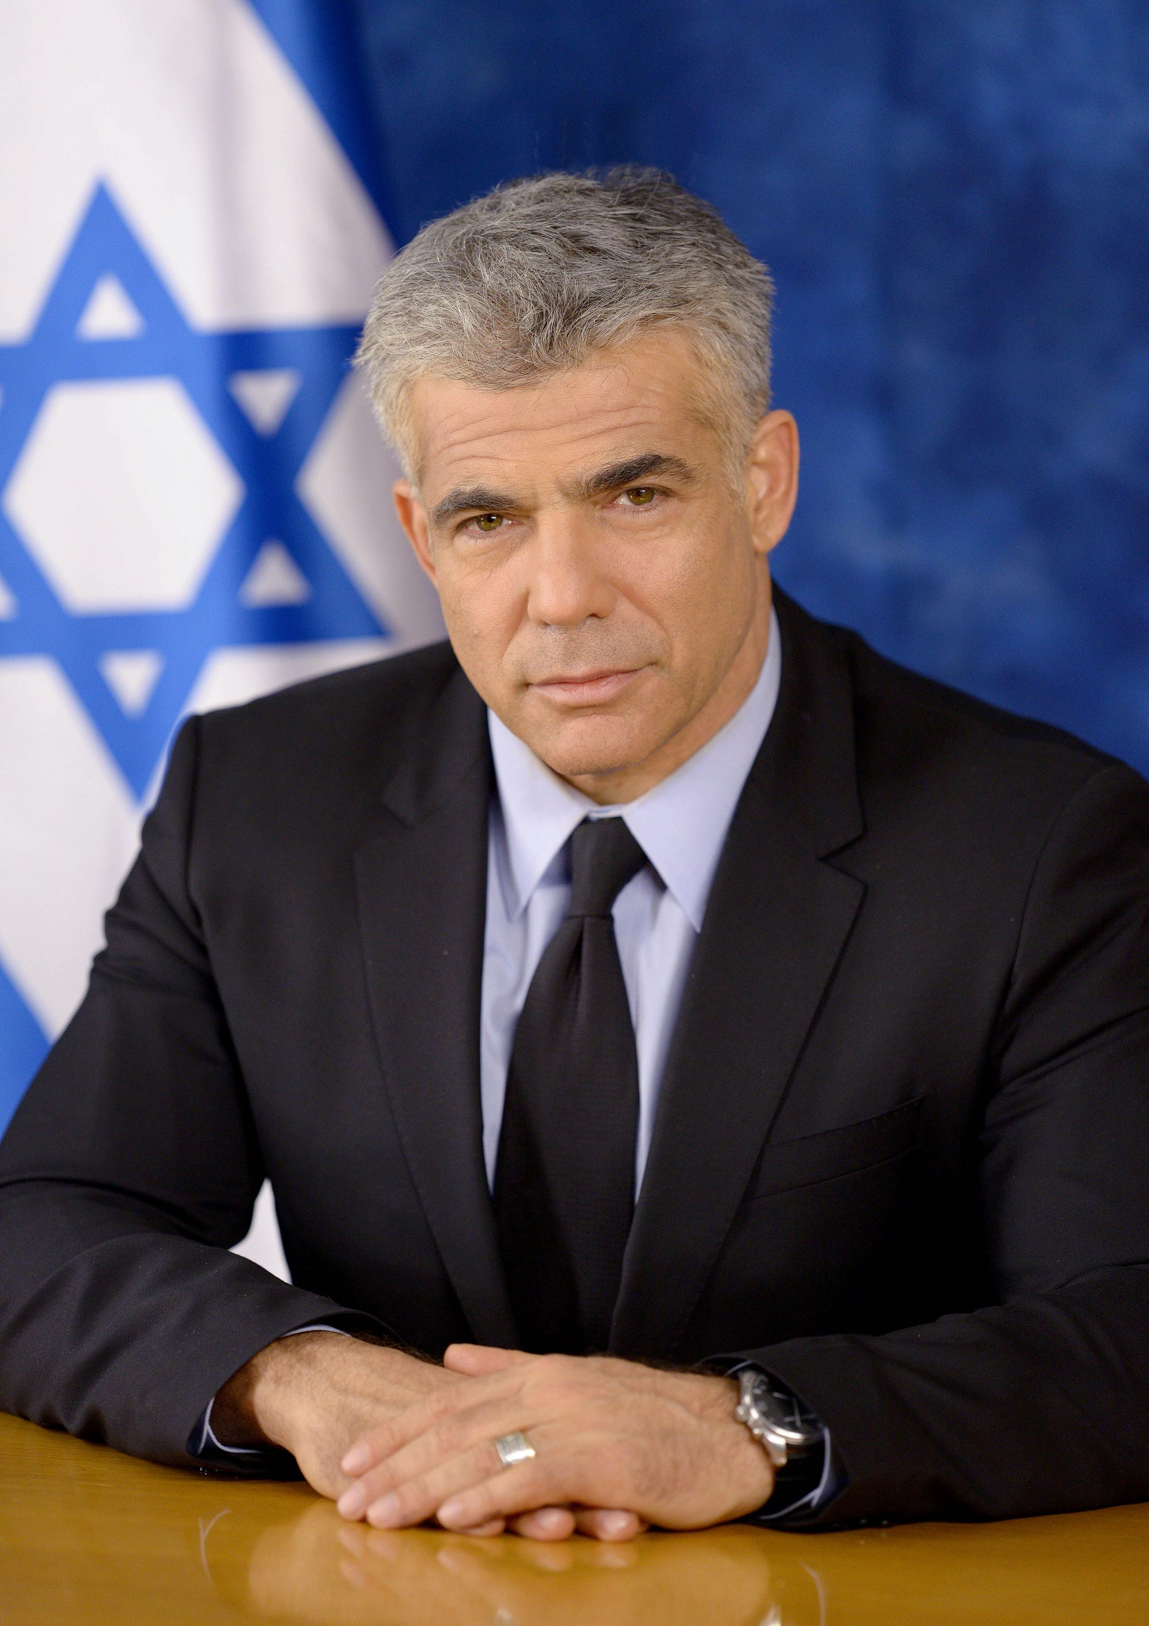
Chairperson of Yesh Atid, MK Yair Lapid

Member of Knesset Yair Lapid is the Founder and Chairperson of Yesh Atid, Israel's largest centrist party. Lapid served as Israel’s Finance Minister and a member of the Political-Security Cabinet, the forum charged with defining and implementing Israel's foreign and defense policies during the 19th Knesset. In the 2015 elections, Yesh Atid secured 11 seats confirming its place as a major actor on the Israeli political scene. In the current Knesset, MK Lapid serves in the Knesset Foreign Affairs and Defense Committee and the Sub-Committee on Intelligence and the Security Services.

Yesh Atid offers a centrist alternative to the traditional left and right wing blocs in Israeli politics. The party remains focused on improving the standard of living in Israel, equality across Israeli society, economic growth , fighting corruption, and a commitment to a regional diplomatic solution based on the principle of two states for two peoples which will ensure Israel's long term security.

Before his entry into politics Lapid was a leading television personality, having anchored the main Friday evening news program for 4 years and prior to that having hosted his own show for 8 years on Israel's Channel 2

Between 2002 and 2013, when he founded Yesh Atid, Lapid wrote a weekly column in Israel's leading daily newspaper, Yediot Ahronot (which often set the public agenda) and he was widely recognized as one of Israel's most influential columnists.

Lapid is also a prolific writer having published 11 books (translated and distributed in numerous countries), a number of which became best-sellers in Israel. He is a two-time recipient of the “Platinum Book Award” by the Israeli Union of Publishers.

Throughout his professional life, Lapid has been active in community affairs. Among the nonprofits in which he volunteered are those assisting the underprivileged such as Aleh, Youth Renewal Fund (YRF) and Miftan Safed (which he chaired). Until he entered political life, he taught civics and media studies at a special "inner-city" high school in one of Tel Aviv-Jaffa's poorest neighborhoods. He was also a partner in the founding of Home for Life, a residential facility for autistic youth.

Yair Lapid lives in Tel Aviv with his wife Lihi and three children.

