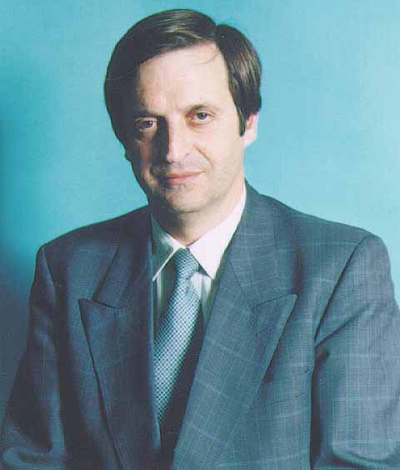
Dan Meridor
Deputy Prime Minister and Minister of Intelligence and Atomic Energy (Likud)

Dan Meridor was born in Jerusalem in 1947, and holds a law degree from the Hebrew University of Jerusalem.

He served in the Israel Defence forces as a tank commander in the 1967 Six Day War and continued in the IDF reserves as a Captain.

A lawyer by profession, he practiced law in Jerusalem from 1973-82.

He served as Cabinet Secretary under Prime ministers Menachem Begin (1982-83) and Yitzhak Shamir (1983-84). In 1984, he was selected to the Knesset.

In the 11th Knesset (1984-88), he was a member of the Knesset Foreign Affairs and Defence Committee and the Constitution, Law and Justice Committee.

From 1988-92 he served as a Minister of Justice and member of the Inner Cabinet.

In the 13th Knesset (1992-96), he was a member of the Knesset Constitution, Law and Justice Committee. In June 1996, Dan Meridor was appointed Minister of Finance, a position he held until his resignation in June 1997. In the 15th Knesset, he chaired the Foreign Affairs and Defense Committee (until August 2001).
Dan Meridor served as Minister without Portfolio, responsible for national defense and diplomatic strategy in the Prime Minister's Office from August 2001 until February 2003.
Meridor has been a Knesset observer to the Council of Europe and has published articles in academic journals. In February 2009, after a six-year hiatus, he was elected to the 18th Knesset on the Likud list.
In March 2009 Dan Meridor was appointed Deputy Prime Minister and Minister of Intelligence and Atomic Energy.
He is married to economist Dr. Leora Meridor. They have four children

