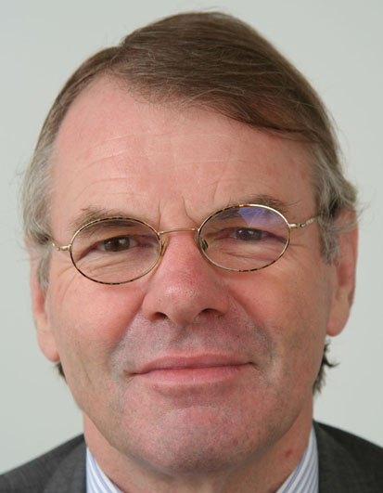

CURRICULUM VITAE

Karel van Kesteren

Born on 7 August 1948. Married, three daughters.

Education: after completing secondary school, studied international law at Nijmegen University, the Netherlands, graduating in 1972.

1972/1973: Military service.

1974: Joined the Dutch Ministry of Foreign Affairs (which is also responsible for development cooperation, with a separate Minister).

1974–1984: Various posts in the United Nations Department, dealing with political issues (among them implementation of international sanctions) and, later, the Specialised Agencies of the UN system. Attended numerous UN and other international meetings (UN General Assembly and sub-committees, annual meetings of UNESCO, IMO, WHO, etc.).

1984–1988: Deputy Head of Mission and Head of Development Cooperation at the Dutch Embassy in Bogotá, Colombia (also covering Ecuador and Panama). Tasks included dealing with large development projects, human rights issues and emergency and reconstruction assistance.

1988–1992: Head of Section at the Ministry in The Hague, working under Minister for Development Cooperation Jan Pronk on development finance issues, including external debt problems of developing countries (Paris Club, HIPC, debt buy-backs). Attended many international meetings and conferences: OECD/DAC, UNCTAD, Paris Club, working groups of like-minded countries, etc. Frequent lectures for a wide range of audiences in the Netherlands on the external debt crisis of developing countries, which was very much in the centre of public attention in those days.

1992–1996: Head of Mission at the Dutch Embassy in Nicaragua, handling the sizeable Dutch aid programme to that country.

1996–1999: Deputy Head of Mission at the Dutch Embassy in Madrid, Spain, emphasis on EU issues, in particular issues related to EU financing.

1999: Director of the Multilateral Development Financing and Macroeconomic Policies Department at the Ministry. Assigned by Minister for Development Cooperation to design and implement the merger of this department with the United Nations Department to form a single department encompassing the whole global multilateral system (United Nations system, Bretton Woods Institutions, regional development banks).

2000–2005: Director of the United Nations and International Financial Institutions Department, dealing with overall coordination of Dutch policies in global multilateral institutions, in relation to both development and foreign policy issues. Preparation of and participation in the UN Millennium Summit in 2000 and the 2005 summit on UN reform. Some of the preparations for the 2005 summit took place under the Dutch presidency of the EU in the second half of 2004, which entailed chairing the EU group of UN directors in Brussels.

Attended meetings and conferences of practically all institutions concerned, often as head of delegation, e.g. to annual meetings of the African Development Bank, the Asian Development Bank, the Inter-American Development BankDB, the UN Conference on Small Island Developing States, the Senior Level Meetings of the OECD/DAC, annual policy consultations with World Bank, IFC, UNDP, UNFPA, WHO, ILO, etc. on special Dutch financial contributions. Dutch World Bank/IDA Deputy in 1999/2000, independent coordinator of the negotiations on the ninth replenishment of the African Development Fund in 2001/2002.

2005– July 2009: Dutch ambassador to Tanzania, leading country in harmonisation and alignment of aid (implementation of the Paris Declaration on Aid Effectiveness), providing first-hand experience with current best practice in development cooperation in the broadest sense. Three countries of co-accreditation, Madagascar, Mauritius and the Comoros, each offering contrasting examples of economic and political developments.

August 2009 – : Dutch Ambassador to Bulgaria.

Publications
Occasional, job-related articles on development financing, the use of aid money for reduction of external debts of developing countries, Dutch-Nicaraguan relations in the 19th century, Official Development Assistance and global public goods, Security Council reform, UN reform in general.

Languages
Dutch (mother tongue), English, French, Spanish, German and (some) Swahili.

Karel van Kesteren
karel-van.kesteren@minbuza.nl

