CURRICULUM VITAE

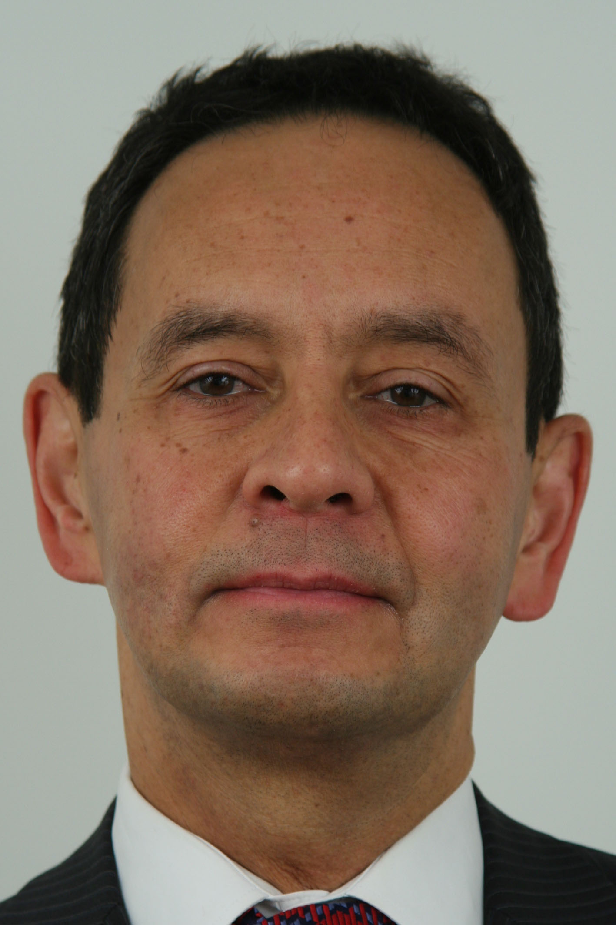

Name: JOZEF WILLEM SCHEFFERS

Date of birth: 21 August 1950

Place of birth: Tomohon (Indonesia)

Education: Master of Law at the Free University in Amsterdam (1973)

Post-graduate course on international political and economic
relations (1974 - l975)

Career: 1975 - 1982

Desk officer of the Disarmament and International Peace Affairs
Section, MFA

1983 - 1985

Head of the Non-nuclear Arms Control and Disarmament Section,
MFA

1985 - 1988

Deputy Chief of Mission at the Royal Netherlands Embassy in Belgrade,
Yugoslavia (First Secretary)

1988 - 1990

First Secretary for Political and Cultural Affairs at the Royal Netherlands
Embassy in New Delhi, India

1990 - 1994

Deputy Director of the Political UN Affairs Department, Head of the
Disarmament and International Peace Affairs Division, MFA

1994 - 1998

Ambassador at the Royal Netherlands Embassy in Zagreb, Croatia

1999 - 2000

Deputy Representative to the UN Security Council/Netherlands Permanent Mission to the UN in New York

2001 - 2005

Ambassador/Inspector at the Organizational Audit and Evaluation Unit, MFA

2005 - 2008

Director of the Asia and Oceania Department

2009 -

Ambassador at the Embassy of the Kingdom of the Netherlands in Hanoi,Vietnam

Relevant information: 1969 - 1978

Editor-in-Chief of the Netherlands’ space magazine Spaceview

1979 - 1985

Secretary of the Government’s Advisory Committee on Disarmament
and International Peace and Security

1998

Author of the book “Ambassador in Zagreb, 1994 –1998”

