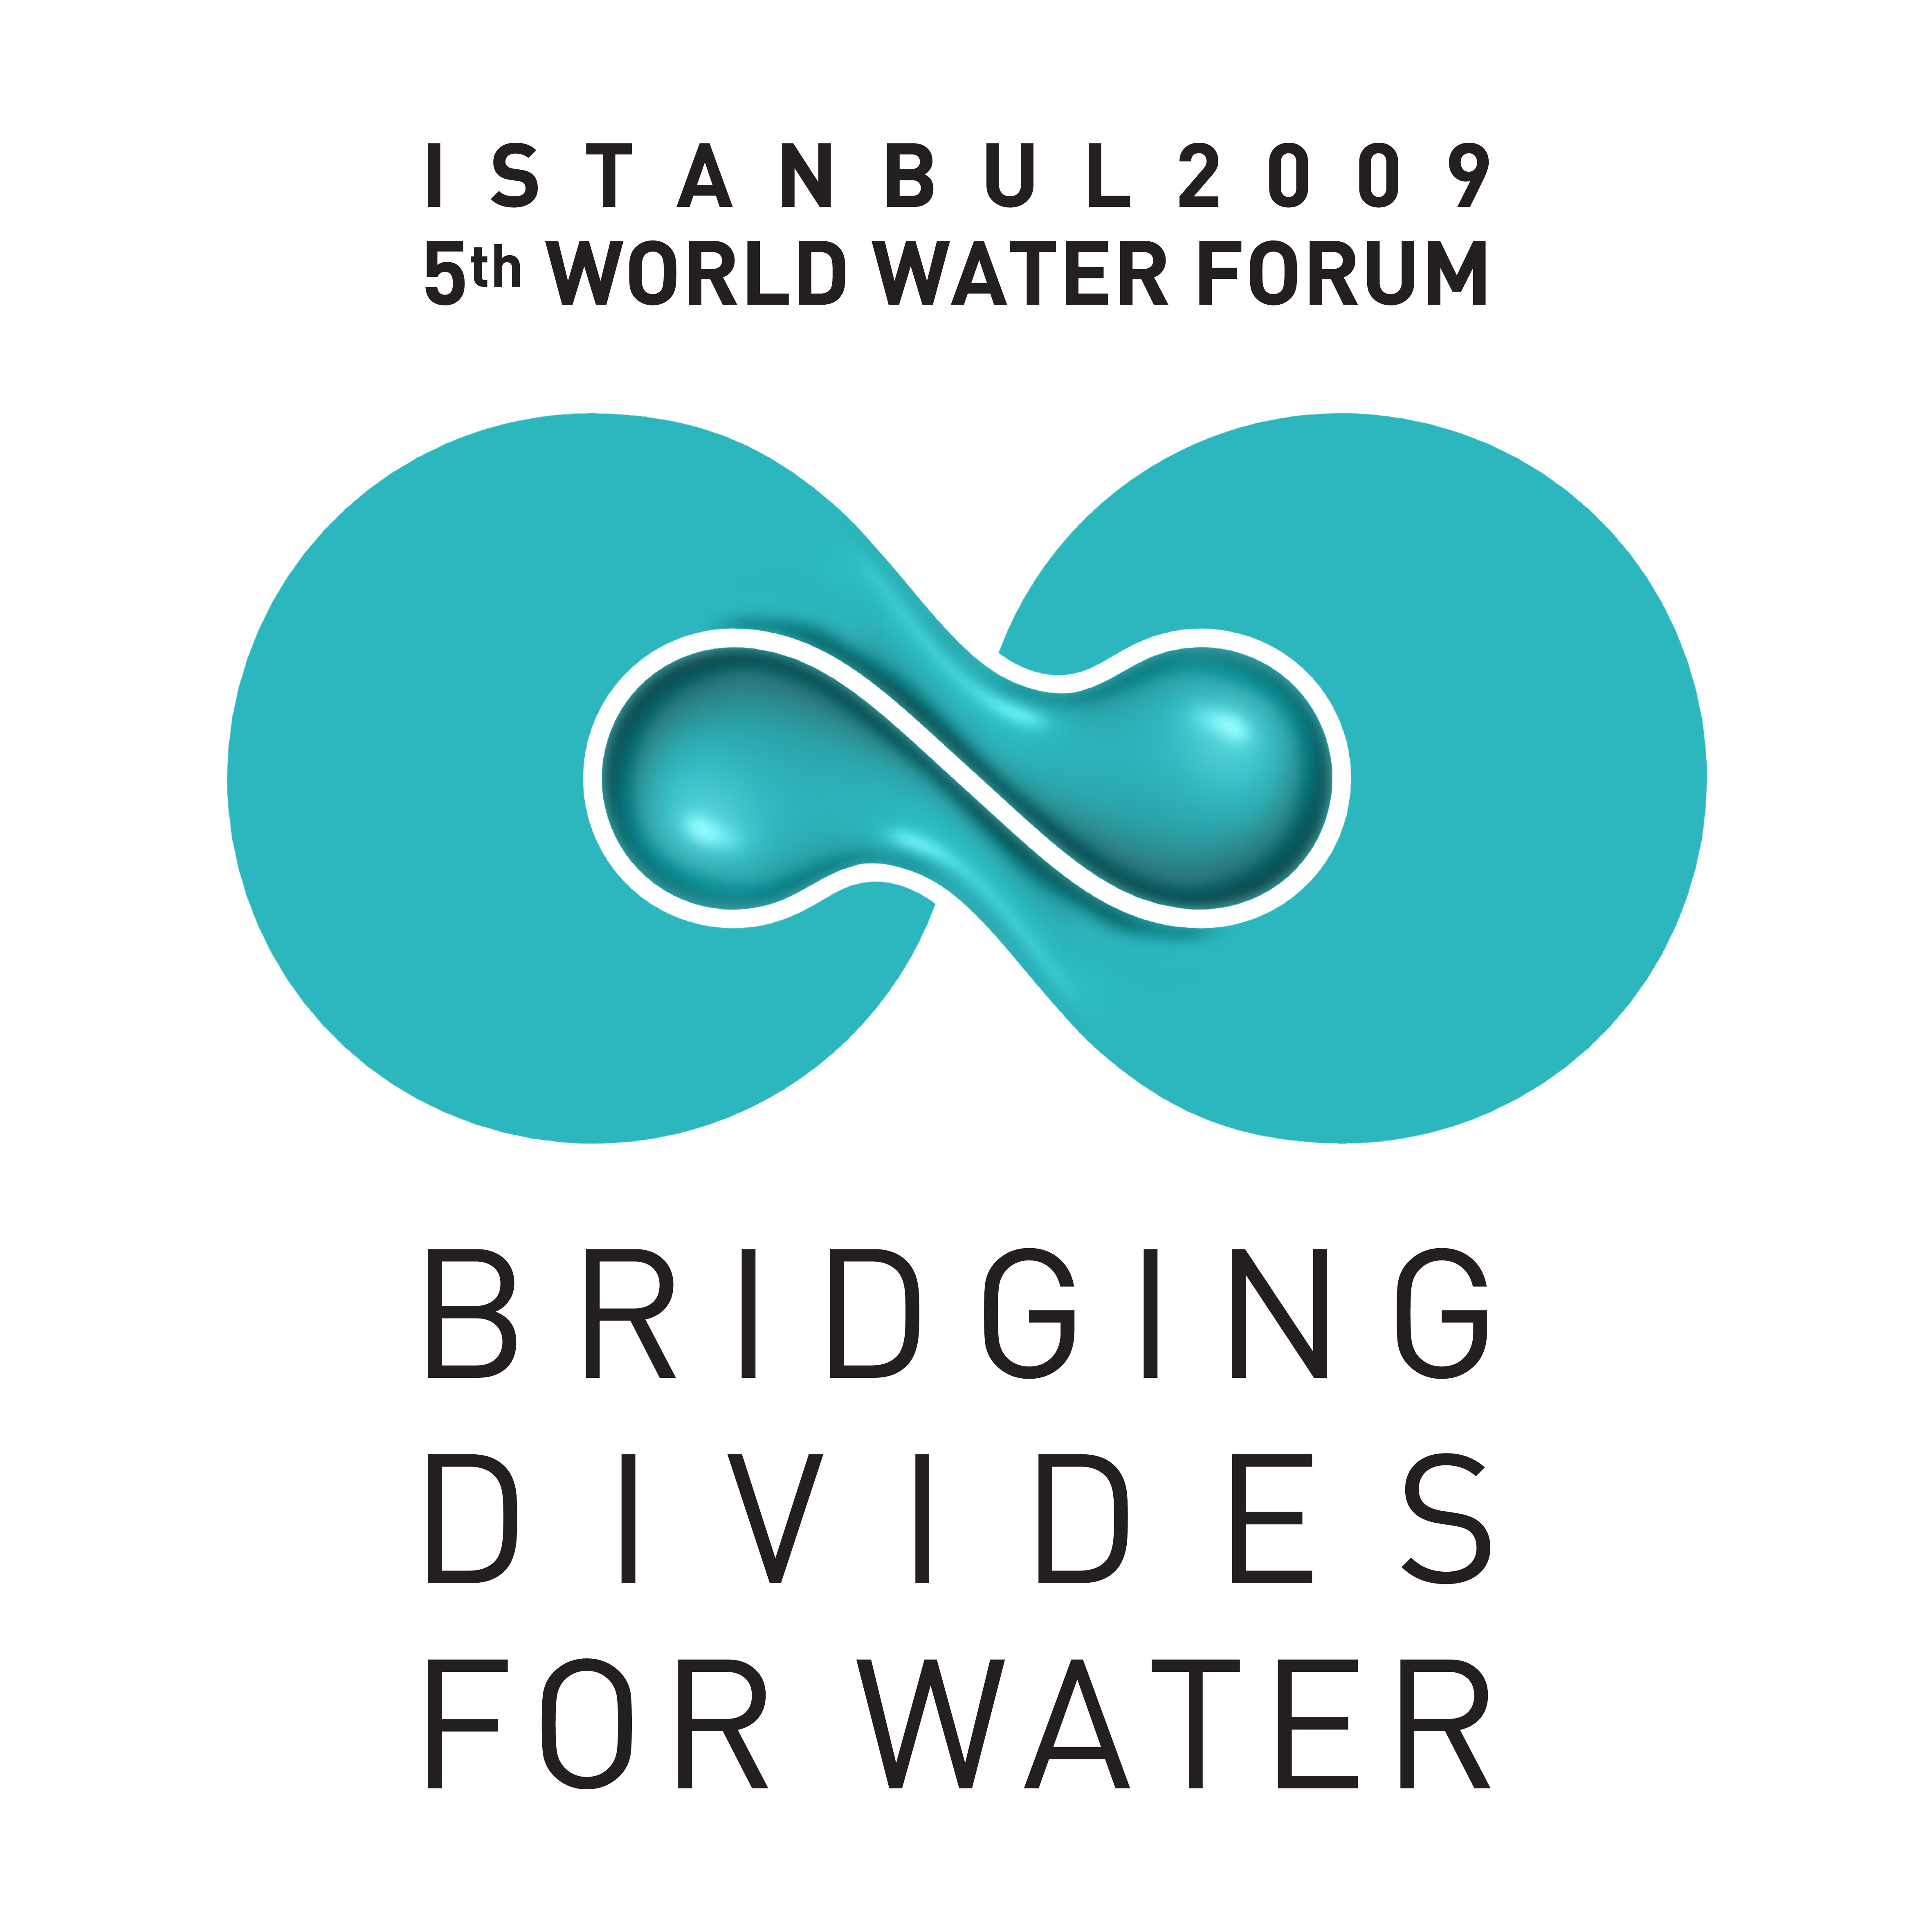
5th World Water Forum

Tentative Session Descriptions

for Parliaments for Water Issues

Right to Water and Sanitation
Topic 4.1 - Implementing the Right to Water and Sanitation for Improved Access
Topic Coordinator: COHRE, Ashfaq Khalfan (Ashfaq@cohre.org)

4.1.1 The Right to Water and Sanitation: True progress towards the MDGs or empty promise? Many States have recognised the Right to Water and Sanitation as part of the right to an adequate standard of living, and between 20 and 30 have included the right to water in national legislation or policies. However, use of the right to drive reform at the national level is embryonic in most countries. What measures need to be put in place by Governments to ensure that these rights impact sector reform, budgeting and policy formulation?
4.1.2 My Water Right! The poor better off with a rights-based approach? In some cases, users have successfully mobilized their communities to advocate for the right to water, resulting in improved access to water. However, many have achieved this result through other means and pathways. Does a rights-based approach truly help to get to scale? In cases where it did, improving the understanding of water rights for people was essential. How can the gained knowledge then be used as a tool truly to gain access?
4.1.3 May I Use the Loo? The Right to Sanitation--a Phantom? The right to water was clarified significantly during the 4th World Water Forum. Today there seems to be a considerable lack of clarity on the right to sanitation. What does it truly entail? And how can its definition contribute to progress on access to sanitation? Following the International Year of Sanitation and the emerging focus on water and sanitation by UN human rights bodies, it is imperative to consider what exactly comprises the right to sanitation and where and how can it be applied.
4.1.4 Water Right in Emergency: Be principled or get practical? In disasters and conflicts, evoking right to water and sanitation principles could support emergency measures. But where does the buck stop? Can entrenching human rights in the humanitarian sector improve the quality of response?. And, does a rights-based approach in this context aid in transitioning from emergency response to long-term rehabilitation and development?

Global Changes

Topic 1.1 – Adapting to Climate Change
Topic Coordinators: CPWC and World Bank, Henk van Schaik (h.vanschaik@unesco-ihe.org, m.bakekr@unesco-ihe.org)

1.1.1 Inconvenient Climate Truths: How to close the gap between knowledge and decision-making? Developing counties need assistance with building environment, energy and climate risk management considerations into the foundations of all efforts to reach the MDG’s. What are the latest scientific evidence, tools and agreements available to decision makers to support them in improved decision making. Contact: CPWC
1.1.2 Climate Change: Friend or Foe? In the face of increasing variability and complexity, water managers are challenged to cope with all the key drivers of global change. However, some of the latest innovations in climate change technology could actually be used to their advantage to predict and alter vulnerability. Contact: GWP
1.1.3 Thinking Beyond the Water Box: What adaptation to global and climate change? Broadening the portfolio of response options is essential if water managers are to adapt successfully to global and climate induced changes. Adaptation requires new thinking “outside of the box” but also needs to be site specific. Contact: IWA
1.1.4 Pay me now or pay me (more) later! Can Climate Change Adaptation be financed? Municipalities, states and private sector entities need to have sufficient funding available to help avert crisis situations before they happen, rather than being forced to resort to more costly reactive responses after the fact. Where and when should money be invested and what is required to concretize commitments? Contact: The World Bank
1.1.5 Running Dry! How to turn droughts into opportunities for better management. Pro-active drought management is central to modern water management, especially in view of the effects of climate change. What are the latest approaches that yield more resilient water systems able to cope with droughts? While frequent droughts could be addressed, what can be done about extreme drought conditions that might become more and more frequent in the near future? Contact: Ministry of Environment, Spain

Topic 1.2 –Water Related migration, changing land use and human settlements
Topic Coordinators: UNU Bonn & GAP, Janos Bogardi, Handa Akçakoca and N. Cakir (Bogardi@vie.unu.edu, hakcakoca@yahoo.com, ncakir@gap.gov.tr)

1.2.1 Water for the Country Mouse: How to meet water needs in rural contexts. In light of the rapidly changing population dynamics of rural to rural migration, water supply and sanitation are impacted by many things in these areas, such as climate change, changing land use, resource disputes and resettlements. Since most of the world’s agriculture springs from these places, the positive impacts of rural migration need to be capitalised upon.
1.2.2 The Good Life in the Slums? The world’s megacities will most likely face the largest migration pressures in the future. Incoming rural populations in slum areas create unexpected pressures on existing infrastructures. What new models exist to develop and manage water and sanitation services in quickly expanding urban areas?
1.2.3 Over Land, Over Seas: Does water accessibility drive cross-border migration? For centuries, populations have moved towards water. But, global changes today can provoke mass displacements that have undeniable impacts on the environment and on water resources. Can improved access, know-how and funding reduce migration by providing solutions to the problems back home?

Topic 1.3 – Managing Disasters
Topic Coordinators: Japan Water Forum & ICHARM, Taeko Yokota, Hikaru Shoji, Katsuhiyo Miyake (yokota@waterforum.jp, shoji@waterforum.jp, miyake@pwri.go.jp)

1.3.1 Disaster – Trialogue: What Government, Society and Science interaction for disaster management? In the context of disaster management strategies, Government, Society and Science must interface effectively. Government, which is responsible for making decisions that are applicable to society as a whole, depends on Science to provide better understanding and to predict natural disasters, so that individuals, organisations and economic entities do not suffer the consequences. Contact: CSIR – to be confirmed
1.3.2 Sounding the Alarm: What Water-Disaster Technologies can save lives and property? Loss of life and livelihoods triggered by water-related disasters are major impediments to sustainable development and poverty reduction. However, a combination of indigenous knowledge, existing technologies and new innovations will most likely hold the key to safeguarding populations. Contact: MLIT Japan and DSI Turkey – To be confirmed
1.3.3 Preparing for the Worst: How can decision-makers become disaster pro-active? Shifting from “Reaction” to “Prevention” of disasters will be key in the future. Water-related disasters have already increased their frequencies and magnitudes. How can political decision-makers be encouraged to create policies that anticipate disasters, rather than concentrating on relief efforts? Which new concepts have been developed to cope with these situations in different contexts? Contact: WMO – to be confirmed
1.3.4 In the Aftermath: How to transition from water - emergency to normality? Swift provision of adequate safe drinking water and sanitation facilities are essential in preventing epidemics during and after disasters and conflicts. However, medium-term solutions are key in establishing normality after immediate emergency response. How can coordination of the various entities on the effected site, such as local Government, international agencies, donor organizations and NGOs, help to streamline efforts, especially in the transition between response and reconstruction phases? Contact: ICRC – to be confirmed
1.3.5 Plugging the Hole: How to maintain infrastructures after mega-disasters? Following last May’s Wenchuan earthquake, the Chinese Government was forced to implement immediate measures to deal with the extensive damage sustained to its hydrological infrastructures. But, beyond remedying the direct impacts, managing and repairing damaged engineering projects proved to be yet another challenge. What are state of the art approaches to face major events across the globe, such as large-scale floods or typhoons, with similar consequences? Contact: Ministry of Water Resources, People’s Republic of China

Transboundary Waters

Topic 3.1 – Basin Management and Transboundary Cooperation
Topic Coordinators: INBO & UNESCO-PCCP, Jean-François Donzier & Lena Salame (jf.donzier@oieau.fr, l.salame@unesco.org)

3.1.1 Boundless Basins: What are the successes and failures of hydro-solidarity? Reviewing the success stories and shortcomings of local, national and transboundary cooperation can help to reason more broadly and identify applicable contexts. That knowledge and experience can then be shared with others, especially in developing countries that have little room for error, in order to implement the approach with the greatest chance for success. Contact: Environmental and Water Resources Institute, ASCE
3.1.2 Your Two Cents: Can stakeholder participation lead to better management? Experience shows that creating a sense of ownership among stakeholders is a key to the success of a project on the ground. However, determining the appropriate ways for developing wide and effective stakeholder participation in particular situations is still a challenge, especially in transboundary contexts. Contacts: UNESCO-ISARM and INBO - provisional
3.1.3 Love Thy Neighbour: How to make transboundary water cooperation a lasting relationship. There are more than 263 transboundary river basins around the world and hundreds of transboundary aquifers on which over 3 billion people depend. Since many countries’ development depends on shared water resources, countless tools have been developed to improve institutional cooperation. Very few, though, are actually sustainable and equitable. Contacts: UNESCO or INBO – provisional
3.1.4 Calling a Spade a Spade: Which tools can help transboundary management? It’s ridiculous to try to dig a hole with a saw or pound a nail with a sponge. Appropriate tools are needed to get the job done right. Likewise, effective operational tools are needed to support transboundary cooperation and sound basin management as a whole. Some tools have already proven to be efficient in certain contexts, but what is the bigger picture?
4.2.2 What are the essential building blocks for managing international waters? Transboundary waters are generally subject to particular legal frameworks and international treaties. Therefore, special institutional arrangements in alignment with those agreements are needed. The key building blocks to constructing truly effective and sustainable transboundary management should made known to all institutions that are entrusted with the task of managing international waters. Contacts: UNDP & GEF

Decentralisation Policies
Topic 4.2 – Institutional Arrangements and Regulatory Approaches for Efficient and Effective Water Management

4.2.3 States United: How best to manage resources in federated countries. In countries where water management is decentralised, states or provinces encounter many specific challenges--not only between states, but also between the central and local Governments: Who develops infrastructure? Who manages? Who pays? Who profits? Who is responsible for what? Institutional arrangements and legal frameworks can help to clear up some of the confusion, while encouraging public participation. Contacts: Agencia Nacional de Agua, Ben Braga (benbraga@ana.gov.br, marie.chabrel@ana.gov.br)

