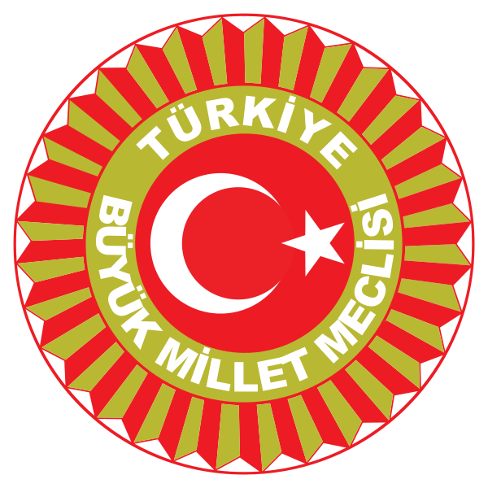
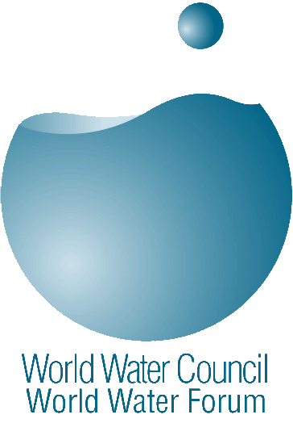
5th World Water Forum
Parliamentarians Process

Concept Note

1. Background

The goal of the Parliamentarians Process of the 5th World Water Forum, or “Parliaments for Water”, is to carry out a coordinated and comprehensive process so that ample opportunity is available for contributions to the 5th World Water Forum Political Process from Parliamentarians from all over the world. The Process aims to share ideas and experiences, to strengthening the knowledge and role of Parliamentarians concerning water issues, to improve the dialogue amongst Parliamentarians as well as with Local and Regional Authority and Ministers, and to define a Terms of Reference for a Water Legislation Helpdesk.

2. Objectives

Discussion/Dialogue on four major Issues

In this open process, Parliamentarians will carry out a dialogue and produce summaries of the discussions and recommendations to improve the work of Parliamentarians on the following four publicized water issues, which are highly sensitive in nature:

  - Implications of the current context of global changes and related needs for adaptation for Parliaments and Parliamentarians
  - Implementation of the right to water and sanitation in national legislation and concrete application for those populations in need
  - Planned management of transboundary water basins and aquifers and promoting cooperation
  - Decentralization policies for the implementation of local water and sanitation services

Prepare outputs and recommendations

For each of these themes, three types of outputs are planned:

- Analyze the current context and prepare a set of issues/activities that are relevant to Parliaments and Parliamentarians;
- Derive lessons from existing legislation in terms of minimum requirements to improve legislation and Parliamentarians work, efficiency of tools implemented and needs for further development or evaluation; and
- Provide aid, through creation of a “Water Legislation Helpdesk”, for Parliaments and Parliamentarians of all countries for the development and implementation of water legislation and in identifying factors of success and failure. The Helpdesk would give advice to Parliamentarians on how to develop or improve national legislation.

In accordance with the overarching theme of the 5th World Water Forum, Parliamentarians will have the opportunity to dialogue and bring their results to Ministers and Local Authorities through a special event, a “Three-level Interaction”, which will take place following the Parliamentarians’ Meeting during the Forum week.
.3. Process

A Preparatory Meeting was held in the Council of Europe, Strasbourg, France, on 6 November 2008, to which all National and Supra-national Parliaments were invited.

During the Strasbourg meeting, more than 70 Parliamentarians as well as many experts coming from Europe, Latin America and Africa, shared their views on the four Issues and on the idea of developing a Water Legislation Helpdesk. They also proposed some ideas to develop further the Parliamentarians Process

In light of the deliberations that took place in Strasbourg, concept notes will be prepared on the above-mentioned four issues and outputs to provide a basis for discussions for the Parliamentarians’ Meeting of the 5th World Water Forum. These notes will be reviewed by a Focus Group comprising a small number of Parliamentarians who will convene in Istanbul on 28 January 2009. Furthermore, these notes will be posted on the Virtual Meeting Space of the 5th World Water Forum (http://portal.worldwaterforum5.org) in order to receive comments from all Parliamentarians interested.

The Focus Group will also discuss the format, programme and possible outcome of the Parliamentarians’ Meeting.

An open invitation to the Parliamentarians Meeting of the 5th World Water Forum will be extended to all National and Supra-national Parliamentarians, as well as Inter-Parliamentary Organizations by the Turkish Grand National Assembly no later than January 2009.

4. Parliamentarians’ Meeting at the 5th World Water Forum (18-19 March 2009)

Discussions on the four main topics as well as “requirements to improve legislation and Parliamentarians work” and “Water Legislation Helpdesk” proposals will be conducted during the Parliamentarians’ Meeting.

The topics of “right to water” and “decentralization” will be discussed by Parliamentarians together with Local Authority Leaders on the second Parliamentarians’ Day.

 | March 18th | March 19th | March 20th
09h30-11h00 | Parliamentarians Dialogue | LA/Parliamentarians Meeting | Trialogue
11h30-13h00 | Parliamentarians Dialogue | LA/Parliamentarians Meeting | Trialogue
14h30-16h00 | Parliamentarians Dialogue | Parliamentarians Dialogue
16h30-18h00 | Parliamentarians Dialogue | Parliamentarians Dialogue
LA: Local Authorities

5. Follow-Up after the 5th World Water Forum.

Following the 5th World Water Forum, Parliamentarians will kindly be asked to pursue their involvement in the process towards the 6th World Water Forum. In this respect, a Focus Group could be established to maintain the dialogue and action in line with the outcome of the 5th World Water Forum and to help developing proposals for the 6th World Water Forum.

