Wolfgang Wagner
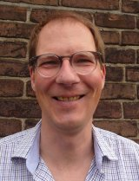
Professor, Multi-layered governance in Europe and beyond (MLG), Vrije Universiteit Amsterdam
Wolfgang Wagner studied Political Science, German Literature and Philosophy in Tübingen (Germany) and Yellow Springs, Ohio (USA). He holds a PhD from the Johann-Wolfgang-Goethe University Frankfurt am Main and taught at the universities of Tübingen, Frankfurt, Konstanz, Darmstadt and Mannheim. Between 2002 and 2007 he worked at the Peace Research Institute Frankfurt (PRIF). He was a visiting scholar at the University of California at Berkeley in 2007 and at the Wissenschaftszentrum Berlin in 2016.
Hisresearch revolves around domestic politics and conflict in liberal democracies. Simply put: what makes liberal democracies resort to armed force? And why do some democracies use force more frequently than others?
This line of research is inspired by the so-called Democratic Peace Theory, i.e. the idea that democracies stand out for not waging war against each other. Together with former colleagues from the Peace Research Institute Frankfurt, particularly Anna Geis and Harald Müller, he has argued that the wars waged by democracies are just as interesting as the absence of war amongst democracies. What is more, there are many additional ways in which democracies differ from other states in international relations, and we have pleaded to broaden research beyond the Democratic Peace narrowly understood towards a research program on “democratic distinctiveness”.

Paul van Hooft
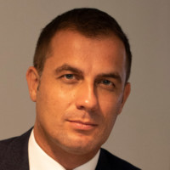
Paul van Hooft is a Senior Strategic Analyst at HCSS and the Co-Chair of The Initiative on the Future of Transatlantic Relations.
He was a postdoctoral fellow from 2018 to 2020 at the Security Studies Program (SSP) of the Massachusetts Institute of Technology (MIT), including as a 2018-2019 Stanton Nuclear Security Fellow. His work focuses on: the origins and logic of American grand strategy; European grand strategy and security; nuclear strategy; Indo-Pacific security, transatlantic relations; alliances; and extended deterrence. Paul attained his Ph.D. in political science from the University of Amsterdam (UVA) and was a Max Weber Fellow at the European University Institute (EUI) from 2016 to 2018. Paul received the 2016 prize from the Dutch and Flemish political science associations for his dissertation on the impact of experiences with war on postwar grand strategy.

